**Exercise 6.**

Design and apply Analog Filters.

Table of Contents

List of Figures 1

Abstract 2

Part 1: Working with WAV files in LTspice 3

Part 2: Design and use filter to remove noise 6

Part 3: Homework 12

# List of Figures

Figure 1 An example of saving wav file. 3

Figure 2 Saved wav file. 3

Figure 3 Signal output. 3

Figure 4 Adding noise to signal (using BV voltage source). 4

Figure 5 Output signal. 4

Figure 6 Adding WAV file to the simulation circuit. 5

Figure 7 Output sample noise. 5

Figure 8 Filter Characteristic. 6

Figure 9 Suggested Circuit Design. 7

Figure 10 LPF Circuit Design. 7

Figure 11 Output LPF. 7

Figure 12 Filter Characteristic 8

Figure 13 Suggested Circuit Design. 8

Figure 14 HPF Circuit Design. 9

Figure 15 Output LPF. 9

Figure 16 Band Pass Filter Circuit Design 9

Figure 17 Band Pass Filter Plot Characteristic 10

Figure 18 Modified Circuit. 10

Figure 19 Unfiltered Output. 10

Figure 20 Filtered Output. 11

Figure 21 Direct Comparison. 11

Figure 22 Filter Characteristic 12

Figure 23 Suggested Circuit Design. 12

Figure 24 HWK Circuit. 13

Figure 25 Filtered Characteristic Comparison. 13

Figure 26 Close up of filtered characteristic. 13

# Abstract

The aims of this laboratory exercise were learning how to design and apply analog filters also attach to LTspice signals from external files.

# Part 1: Working with WAV files in LTspice

For begin our exercises we will conduct an analysis of the amplifier circuit for nominal values. Therefore

**Saving signal as a WAV file**

In the below please see an circuit with necessary spice directives to save files. See a new directive used being .wave. How it works is that this is just a text directive, the functioning is explained .wave “filename” nbits, sample_rate V(node_name). Nbits is commonly 16 bits however the sample rate can be 8000 16000 44100, for example .wave “my_audio_file.wav” 16 16000 V(OUT)

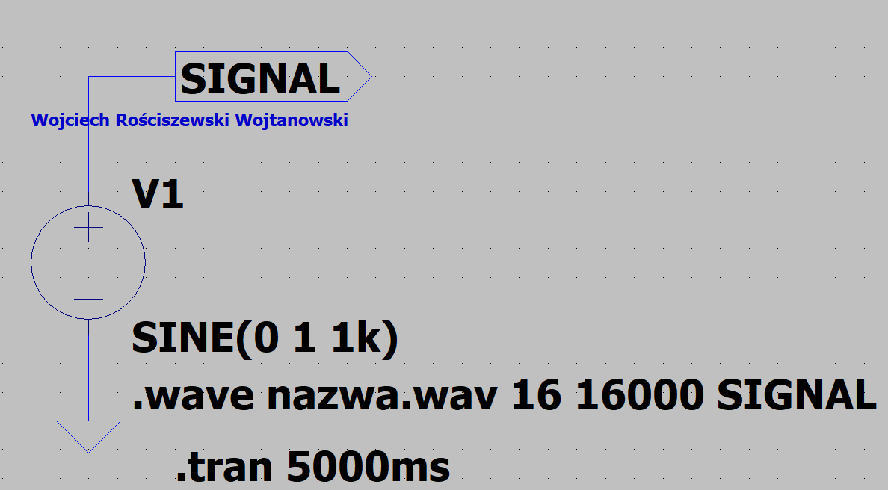

Figure 1 An example of saving wav file.

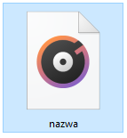

Figure 2 Saved wav file.

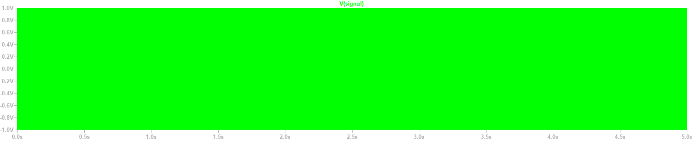

Figure 3 Signal output.

Please see that the circuit operates successfully, and the file is saved, inside the file we have our sinusoidal waveform.

The next step is to create a circuit to add noise to our original signal, therefore we must firstly create our sinusoidal generator and our noise generator, then we can save these samples.

Below please see a circuit built from an op-amp, noise is being added using the BV voltage source.

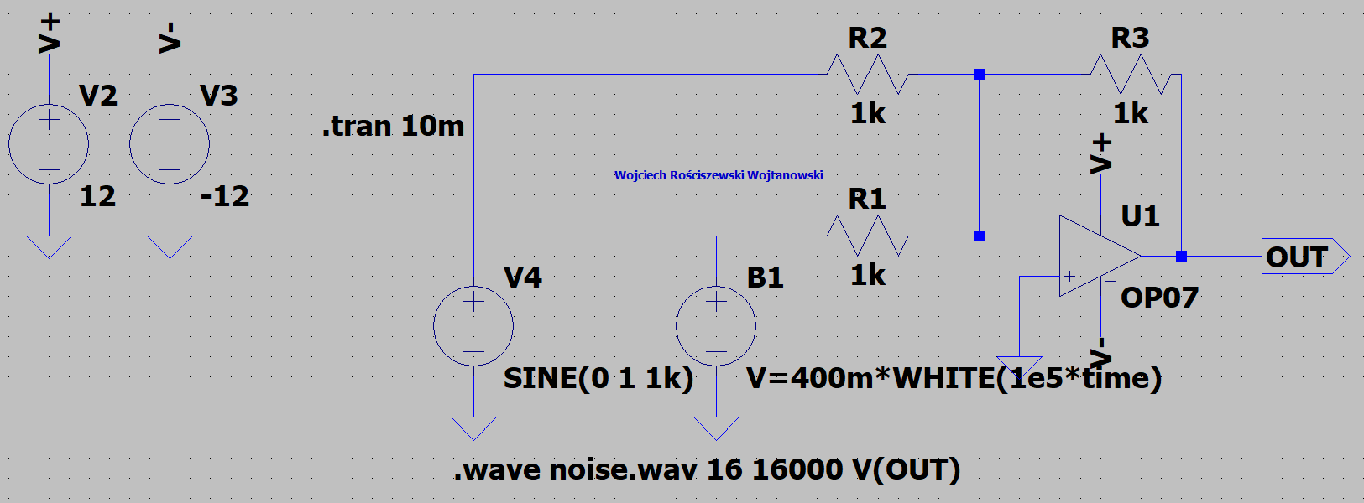

Figure 4 Adding noise to signal (using BV voltage source).

Below please see the output characteristic that should be presented in the file, we should see a simple sinusoidal waveform with noise. Correct, this is what we see, circuit works.

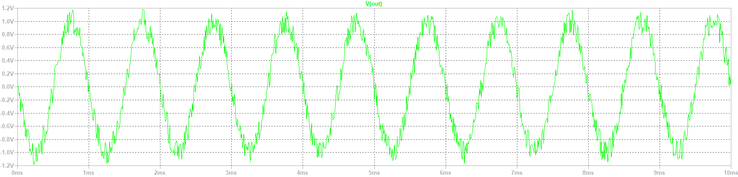

Figure 5 Output signal.

File has been saved, when the sound is played back we hear our sinusoidal signal but this time with almost the sound of compressed air being released and blown, or another comparison could be to an old radio when tuning in and out of channels.

**Adding WAV file to the simulation**

The next step in the exercise is to add a wav file into our simulation, therefore we need some .wav noise to be inserted into our simulation. To do this we should use the spice directive wavefile, it is found in the voltage source. Wavefile=”file_name.wav” chan=0.

In the below please see such tested and built circuit.

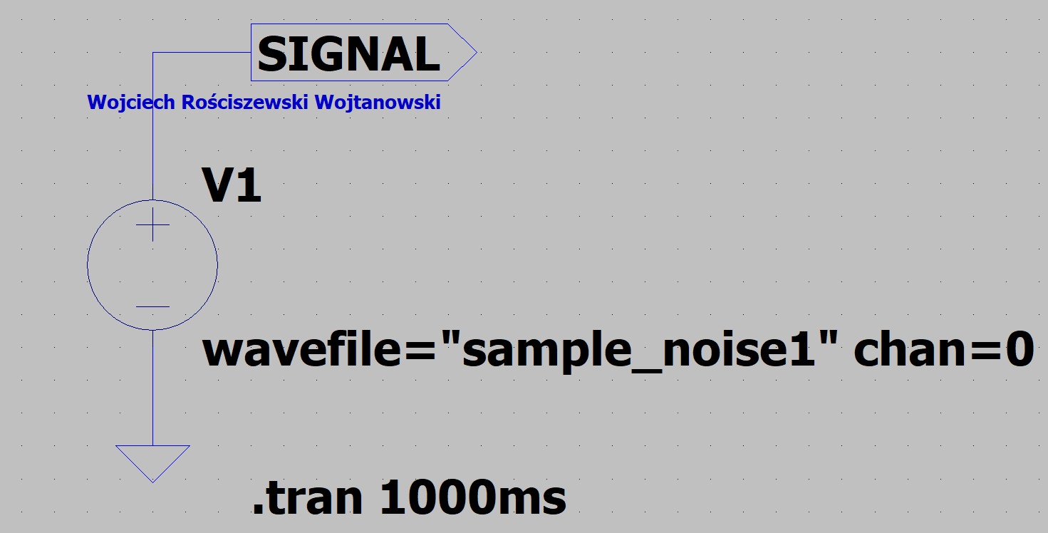

Figure 6 Adding WAV file to the simulation circuit.

In the below please see the output of our simulation. Our sample noise used were howling wolves. We see the loud howls with the greatest peak. Signal has been run successfully.

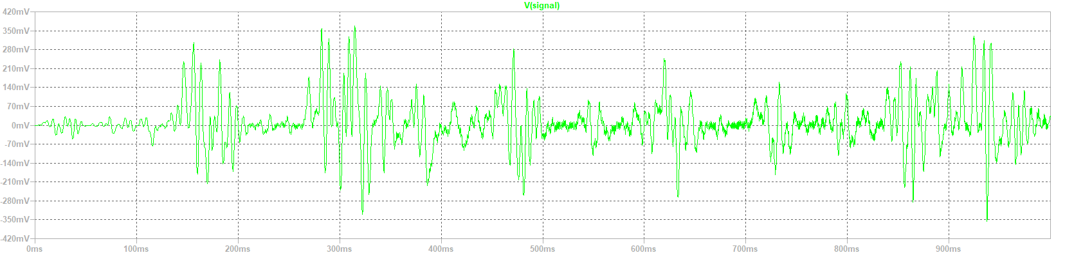

Figure 7 Output sample noise.

# Part 2: Design and use filter to remove noise

For this part we will design filters for our systems, the parameters for each are provided in each filter category below. To aid the building of the filters we will use an online filter design page https://tools.analog.com/en/filterwizard/ this is to seek reference of how the circuits should be built.

**Low-Pass Filter**

The task for this filter is to design an active filter, below are the properties:

* low pass,
* gain: 1 V/V,
* cut-off frequency: 2500 Hz,
* filter order: 4.
* filter response: Bessel
* select multiple-feedback (MFB) circuit implementation
* Design the filter, assuming the values of E96 series resistors (1%) and capacitors from the E24 series (5%)

In order to complete this task, we must create the filter with the properties in the above, then using AC Sweep analysis we must perform the frequency analysis of our tested filter. We can then compare the determined characteristic with the design assumptions.

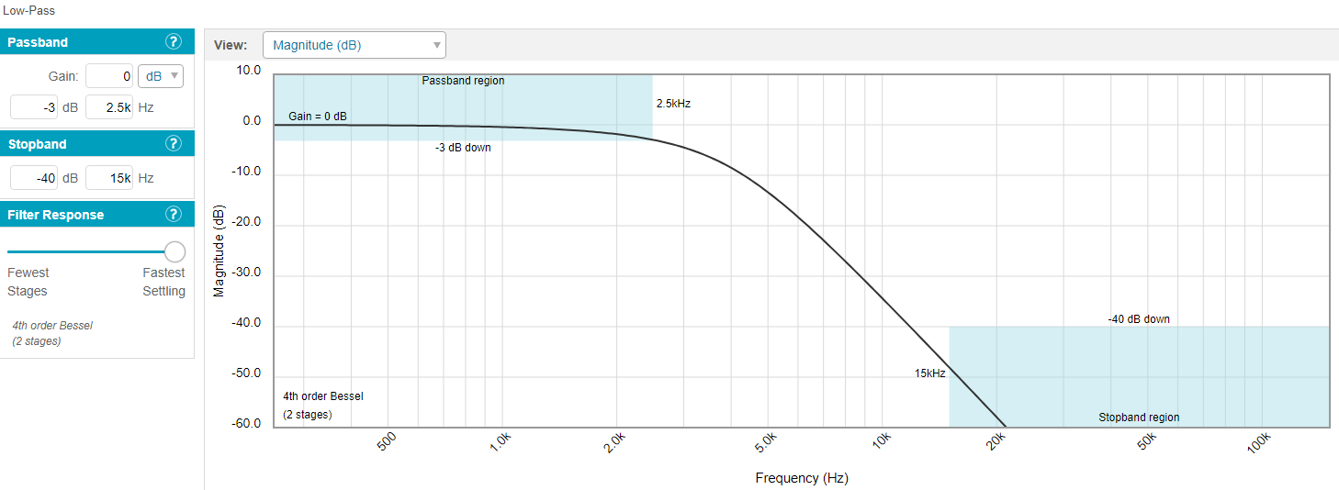

Figure 8 Filter Characteristic.

In the above please see our suggested filter characteristic matching our parameters provided. We see our passband region, out stop band region, we see that the stop pan is set to 2.5kHz meaning all is correct.

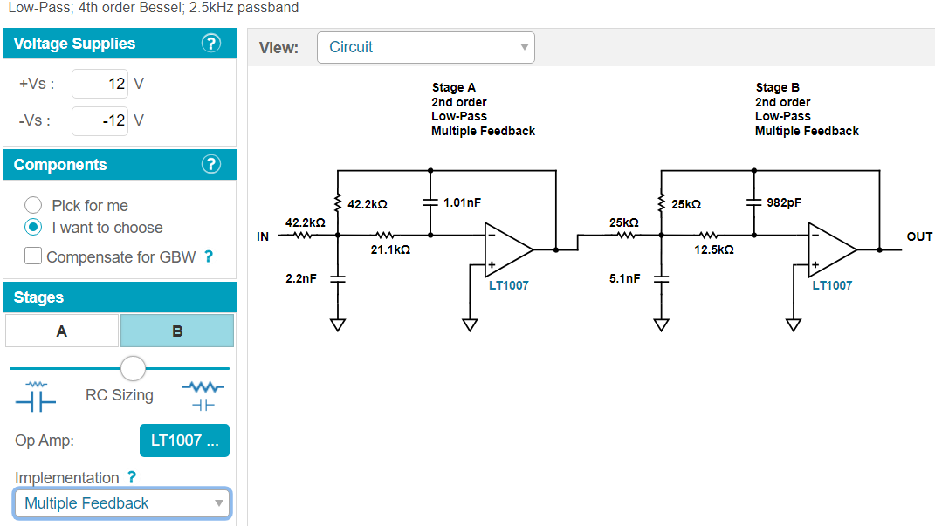

Figure 9 Suggested Circuit Design.

In the above please see the suggested design circuit of our filter, we see two low pass multiple feedback filters connected in series. This is correct. In the below please see the remade circuit in LTspice program.

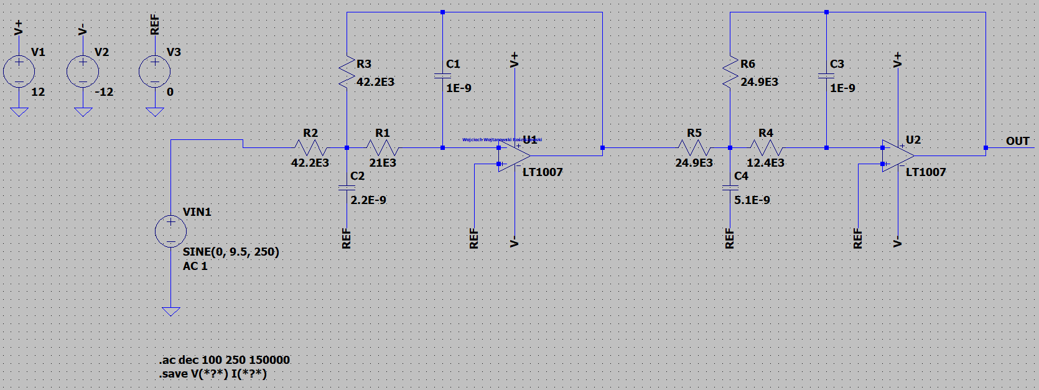

Figure 10 LPF Circuit Design.

As we can see the circuit has been designed, notice that we’re in AC analysis mode.

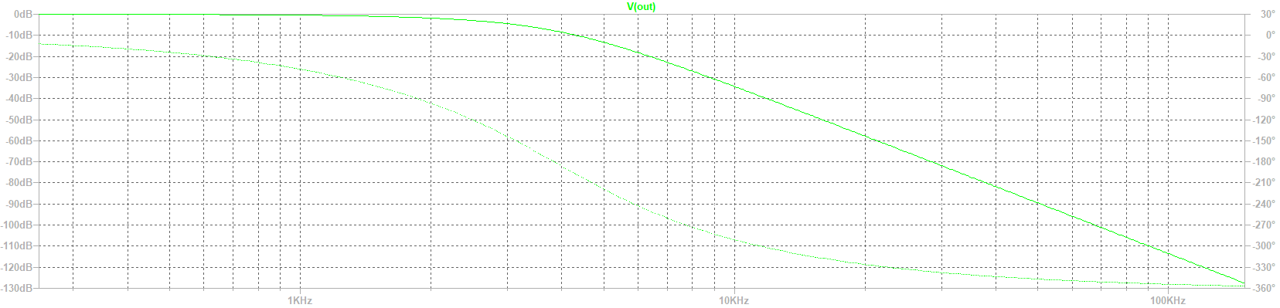

Figure 11 Output LPF.

**High-Pass Filter**

The task for this filter is to design an active filter, below are the properties:

* high pass,
* gain: 1 V/V,
* cut-off frequency: 500 Hz,
* filter order: 4.
* filter response: Bessel
* select multiple-feedback (MFB) circuit implementation
* Design the filter, assuming the values of E96 series resistors (1%) and capacitors from
* the E24 series (5%)

In order to complete this task, we must create the filter with the properties in the above, then using AC Sweep analysis we must perform the frequency analysis of our tested filter. We can then compare the determined characteristic with the design assumptions.

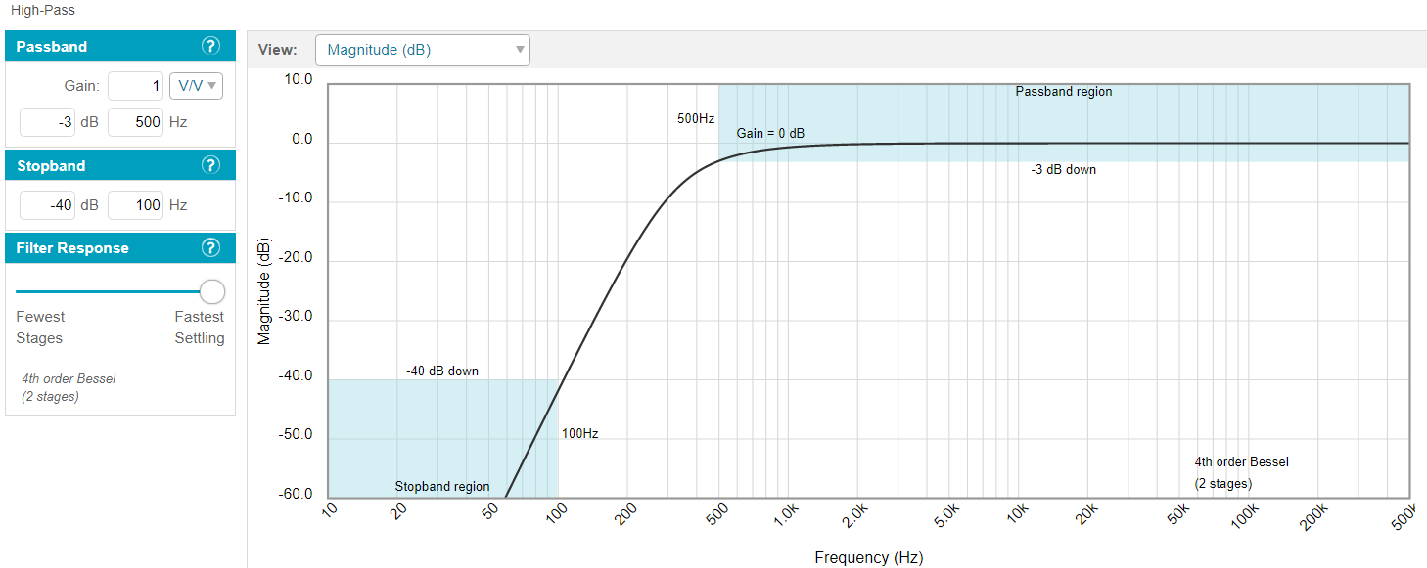

Figure 12 Filter Characteristic

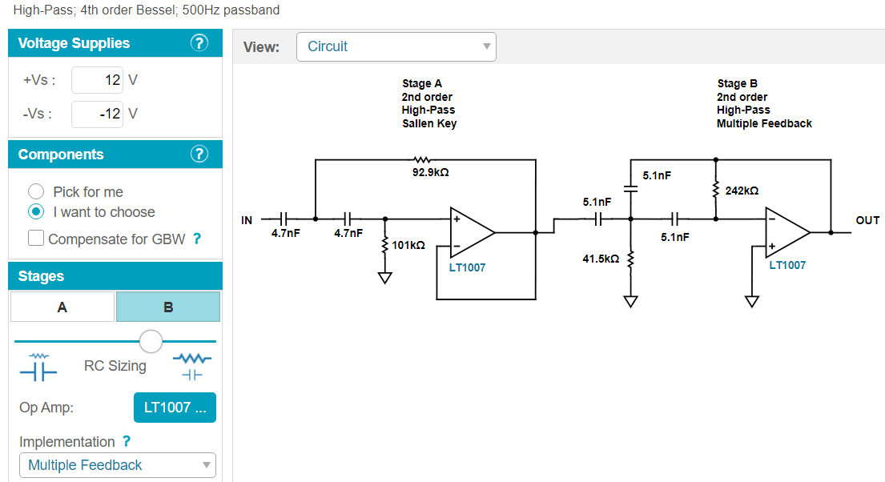

Figure 13 Suggested Circuit Design.

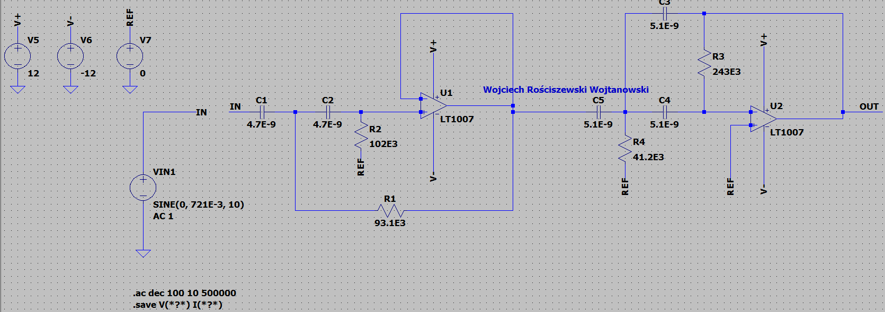

Figure 14 HPF Circuit Design.

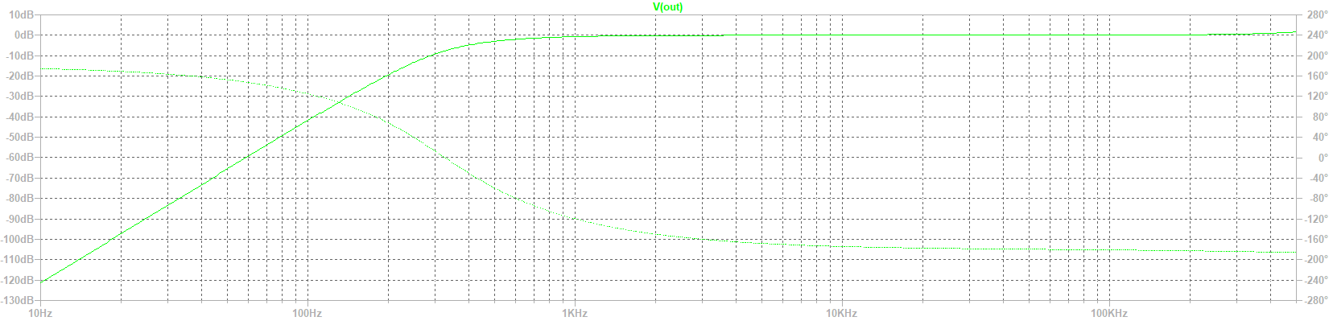

Figure 15 Output LPF.

**Band-Pass Filter**

For this task we do not need parameters as to create a band-pass filter we must combine the low-pass to the high pass filter in series. In order to complete this task, we must create the filter with the properties in the above, then using AC Sweep analysis we must perform the frequency analysis of our tested filter. We can then compare the determined characteristic with the design assumptions.

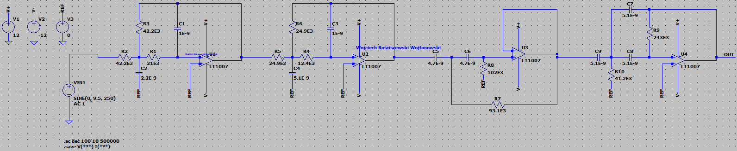

Figure 16 Band Pass Filter Circuit Design

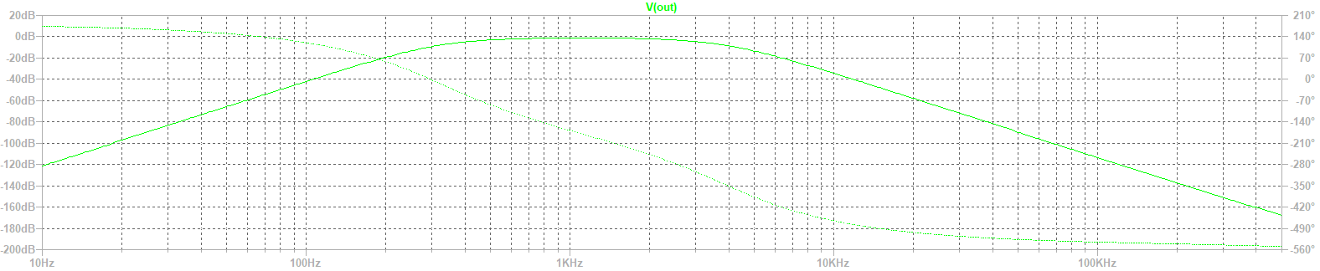

Figure 17 Band Pass Filter Plot Characteristic

As we can see in the output of the AC analysis, we see out bandpass output characteristic, meaning that our filter is working.

**Filtering Noise**

For this part of the exercise we must insert the wav file being our sample noise 2 of the bird sounds, we will then filter the noise and save the result of filter into a new file, we will then compare the effects between original and filtered.

I have modified the circuit from the band-pass section and inserted the bird chirp sounds, below please find the modification as well as the output characteristic.

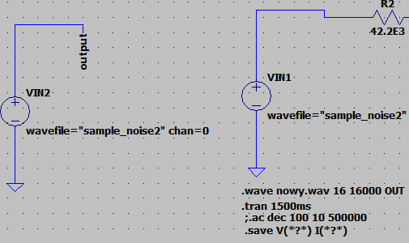

Figure 18 Modified Circuit.

Please also find the normal output characteristic for comparison.

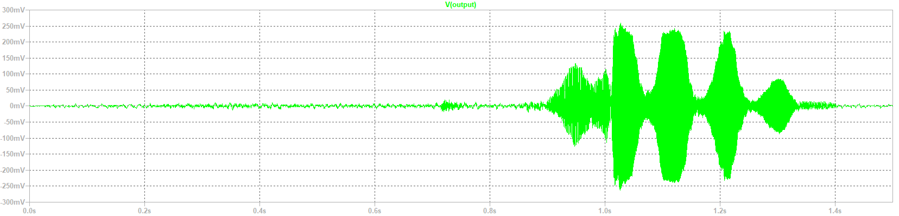

Figure 19 Unfiltered Output.

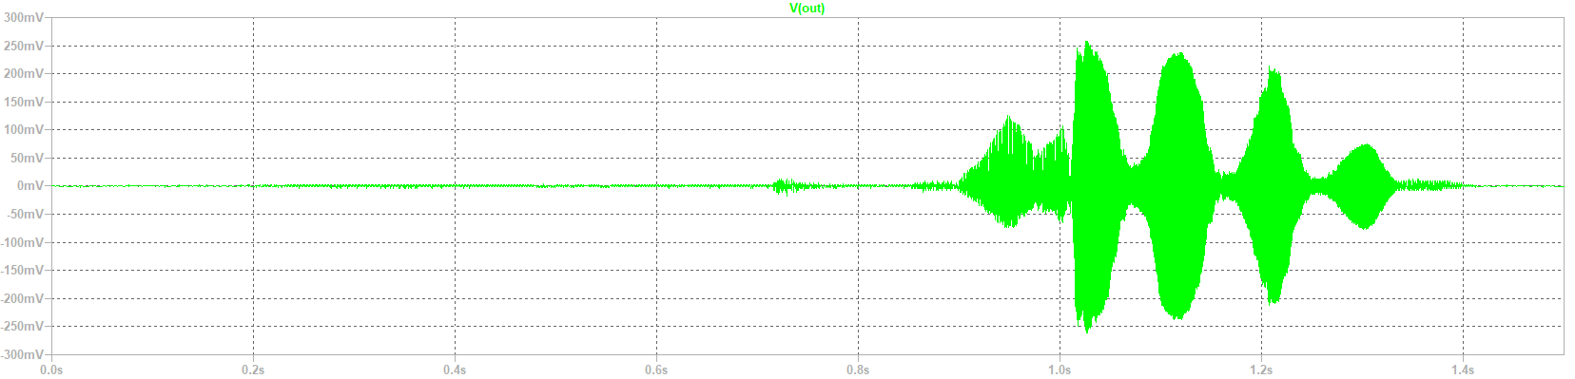

Figure 20 Filtered Output.

After hearing the two files, I hear that the noise has been reduced successfully I hear no static, but the noise of the birds is slightly more quiet. Notice on the output characteristics that the filtered output has much smoother curves, suggesting less noise in comparison to the unfiltered output.

Here is direct comparison:

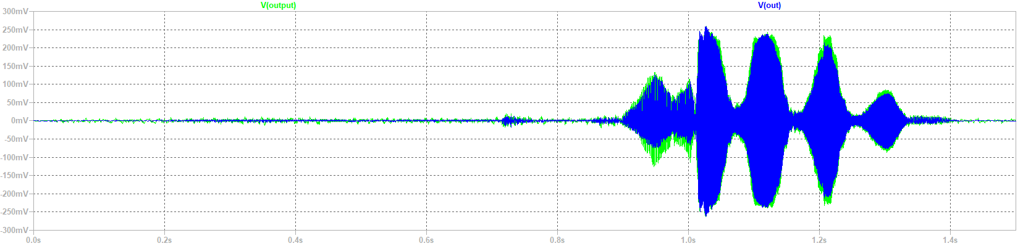

Figure 21 Direct Comparison.

# Part 3: Homework

For the next part of the exercise we must use the previously used website as guidance in order to create and design a filter for one band pass, so the properties are:

* Passband: 1K,
* Stopband: 5k,
* Center Frequency: 1kHz,
* 6th Order Butterworth
* E96 series resistors (5%)
* E24 series capacitors (10%)

Then we must repeat the noise removing process.

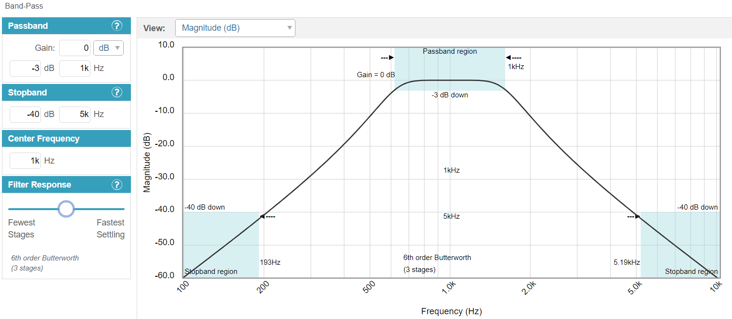

Figure 22 Filter Characteristic

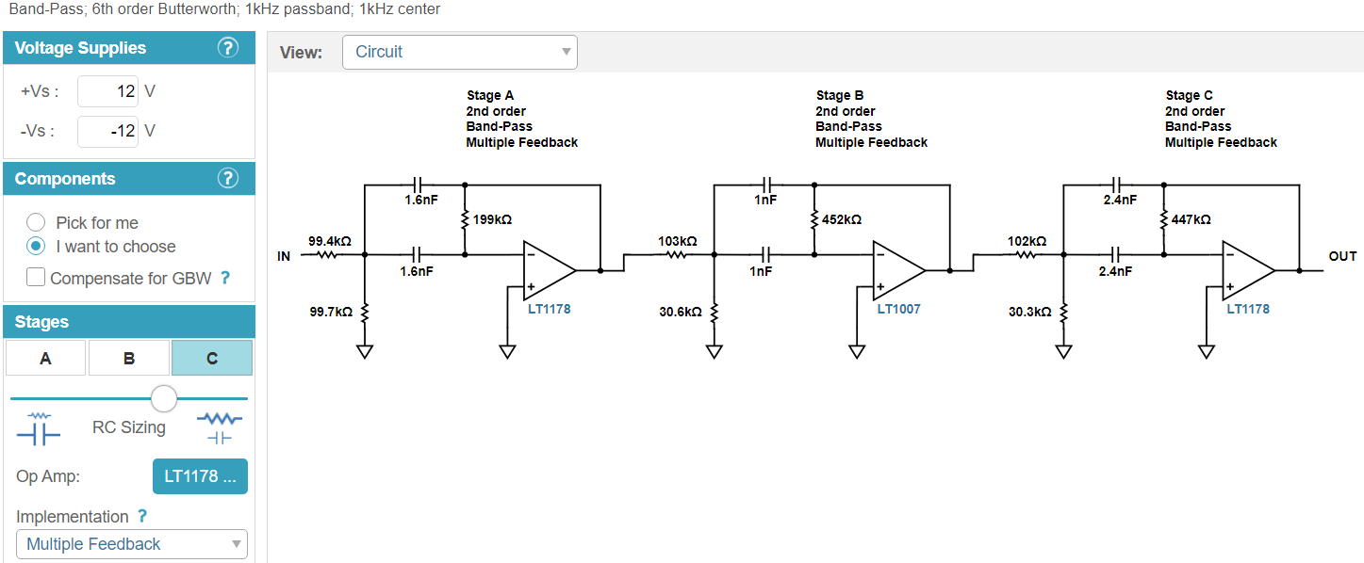

Figure 23 Suggested Circuit Design.

In the above please see the suggested design circuit of our filter, we see two low pass multiple feedback filters connected in series. This is correct. In the below please see the remade circuit in LTspice program.

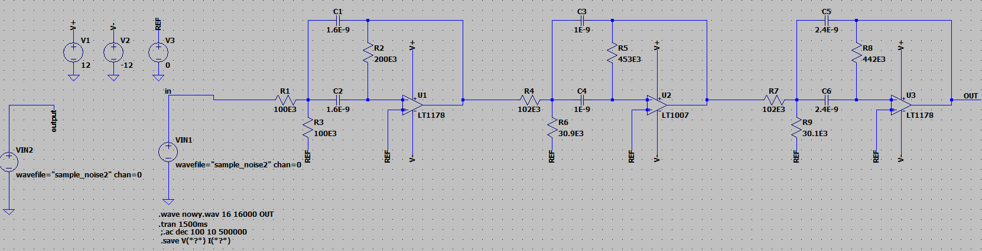

Figure 24 HWK Circuit.

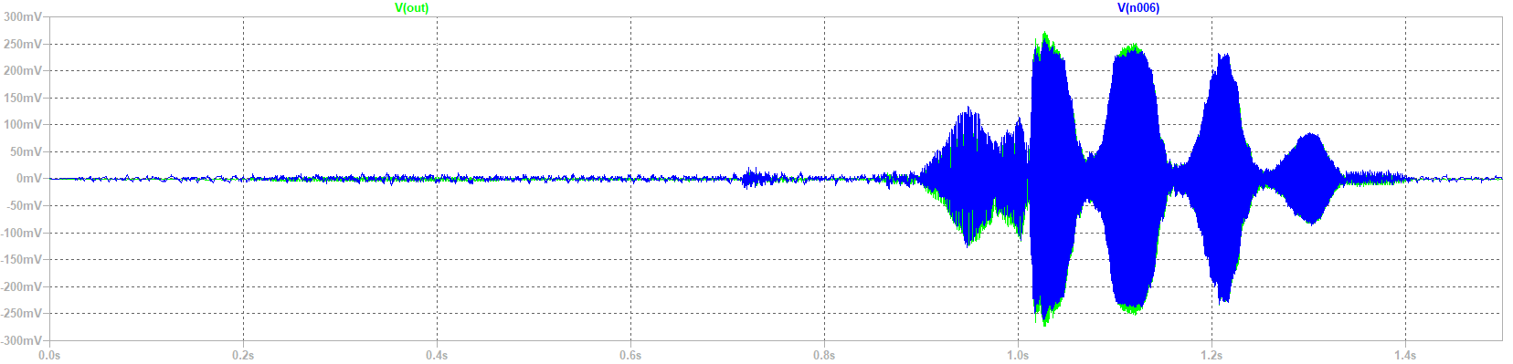

Figure 25 Filtered Characteristic Comparison.

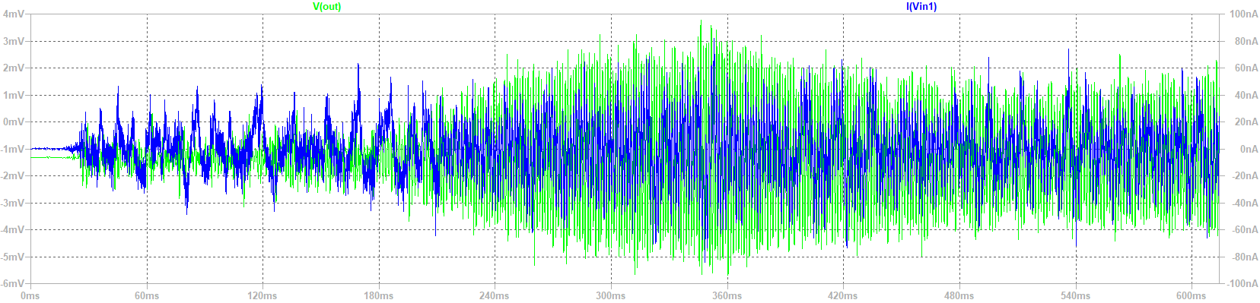

Figure 26 Close up of filtered characteristic.

Please see in the outputs that the output characteristic (green) is more smoother however that doesn’t mean it should be smaller than the original signal, what we see here is positive effects of our band-pass filter.